TerraNova: A Precision Irrigation Management System for Sugarcane Estates

Detailed Project Report
Submitted by
Sushant Samant (16010124059)
Diva Shah (16010124070)
Palak Sanklecha (16010124063)
B.Tech Computer Engineering
Third Year / Semester: V
Faculty: Dr. Shruti Jhavkar
Academic Year: 2026–2027
Mini Project: FSD-MERN Stack
GitHub Repository: https://github.com/sushantsamant-616/terranova

Table of contents
1. Introduction 5
1.1 Background 5
1.2 Problem Statement 5
1.3 Proposed Solution 5
1.4 Objectives and Scope 6
2. REQUIREMENTS AND TECHNOLOGY STACK 7
2.1 Users and Functional Requirements 7
2.2 Non-Functional Requirements 7
2.3 MERN Technology Stack 8
3. SYSTEM DESIGN 9
3.1 System Architecture 9
3.2 Modules and Workflow 10
3.3 Database Design 12
3.4 API Design 13
4. APPLICATION DESIGN AND IMPLEMENTATION 14
4.1 User Interface and Navigation 14
4.2 Frontend Implementation 15
4.3 Backend and API Implementation 16
4.4 Database and CRUD Implementation 16
4.5 Validation and Error Handling 17
5. TESTING AND RESULTS 18
5.1 Testing Approach 18
5.2 Test Cases 18
5.3 API and Database Verification 19
5.4 Final Results 19
6. GITHUB AND DEPLOYMENT 20
6.1 GitHub Repository 20
6.2 Deployment Details 20
7. CHALLENGES AND INDIVIDUAL CONTRIBUTIONS 21
7.1 Challenges and Solutions 21
7.2 Individual Contributions 21
8. CONCLUSION AND FUTURE SCOPE 23
8.1 Conclusion 23
8.2 Future Scope 23
References 24

List of figures
Figure 1 – System architecture of TerraNova 9
Figure 2 – Request and response path for scheduling an irrigation event 10
Figure 3 – Application workflow and data flow 11
Figure 4 – Life cycle of an irrigation event 11
Figure 5 – Database design (collections and relationships) 12
Figure 6 – Overview page with KPI cards and plot status 14
Figure 7 – Irrigation page with the themed dropdown open 15
Figure 8 – Reports page with weekly water chart and plot performance 15
Figure 9 – Output of the automated test suite (npm test) 19
Figure 10 – MongoDB Compass showing the terranova database and plots collection 19
Figure 11 – GitHub repository structure 20

List of tables
Table 1 – Functional requirements 7
Table 2 – Non-functional requirements 7
Table 3 – Technology stack 8
Table 4 – Modules and their main functions 10
Table 5 – Collections and important fields 12
Table 6 – REST API endpoints 13
Table 7 – CRUD operations in the application 17
Table 8 – Validation and error-handling examples 17
Table 9 – Selected test cases and results 18
Table 10 – Deployment details 20
Table 11 – Challenges, solutions and outcomes 21
Table 12 – Individual contributions 21

1. Introduction

1.1 Background
Sugarcane is one of the most water-intensive crops grown in India. A single hectare can need many lakh litres of water over a season, and the timing of each irrigation decides how well the crop grows. On most estates the decision is still taken by eye: a supervisor walks the plots, looks at the soil and the leaves, and orders the pump to be switched on. This works on a small scale but leads to two costly mistakes: over-irrigation, which wastes water, electricity and fertiliser, and under-irrigation, which stresses the crop and reduces yield.
Low-cost soil-moisture sensors now make it possible to measure what is happening in each plot, but readings are of little use if they stay on a device or in a spreadsheet. The farm manager needs a single place that shows which plots are dry, warns early, suggests what to do, records what was done and reports how much water and money was used.
This project, TerraNova, is a web application built for that purpose. It combines live plot monitoring, automatic alerts, rule-based irrigation recommendations, scheduling and reporting in one MERN-stack application (MongoDB, Express.js, React and Node.js), so that decisions are based on data rather than guesswork.

1.2 Problem Statement
Farm managers and agronomists on a sugarcane estate lack a simple, unified tool to monitor soil moisture across many plots and to plan, record and review irrigation. Without it, water is applied on fixed schedules or by judgement, dry plots are noticed late, sensor failures go unseen, and there is no reliable record of how much water was used or what it cost. The required improvement is a secure, easy-to-use web application that collects sensor data, flags problems automatically, recommends actions, tracks every irrigation event and produces reports that can be exported or printed.

1.3 Proposed Solution
TerraNova is a role-based web application. A typical user flow is:
- Sign in as a user or an administrator; the server issues a signed token valid for seven days.
- Monitor the Overview page: every plot is shown with its moisture, vegetation index (NDVI), a colour-coded status (Optimal, Watch or Critical) and any irrigation already planned.
- Respond to alerts and recommendations: the system opens alerts for dry plots, silent sensors and low batteries, and recommends irrigation or fertigation, or advises holding back when heavy rain is forecast.
- Schedule and record an irrigation or fertigation event; the litres required are calculated from plot area, depth and drip factor. The event is started, completed or cancelled and every step is logged.
- Review the Reports page for water used, pumping cost, events and per-plot performance, and export the data to Excel or CSV or print it as an A4 PDF report.
In MERN terms, a React + TypeScript single-page application provides the interface and talks to a Node.js / Express REST API through Axios. The API validates every request, applies the business rules and stores all data in MongoDB, using schema validation, indexes, aggregation pipelines and views.

1.4 Objectives and Scope
- Build a secure MERN application with separate user and administrator access.
- Display live soil-moisture and sensor status for every plot and refresh it automatically.
- Detect problems automatically and raise, acknowledge and resolve alerts without manual effort.
- Generate irrigation and fertigation recommendations from moisture, trend, salinity and the weather forecast.
- Store all data in MongoDB with validation, indexes and views, and provide full create, read, update and delete operations for plots, sensors, events and team members.
- Produce exportable and printable reports (Excel, CSV and PDF) and an audit trail of important actions.
Included in scope: the website, the REST API, the MongoDB database with sample data, a built-in sensor simulator for demonstration, a device ingest endpoint with API-key authentication, optional e-mail alerts and invitations, light and dark themes, and an automated API test suite.
Not included: physical valve or pump control, a native mobile application, delivery of SMS and push notifications (the preferences are stored but nothing is sent), and cloud deployment. These are listed as future scope in Chapter 8.

2. REQUIREMENTS AND TECHNOLOGY STACK

2.1 Users and Functional Requirements
The application has two kinds of user. A User (for example a farm supervisor) can view and operate everything except the Admin area. An Admin (for example the estate manager) additionally configures the system. Table 1 lists the functions that are implemented.
Table 1 – Functional requirements
ID | User / Function | Description
FR1 | Authentication and roles | Sign in with e-mail and password; User and Admin roles; admin-only actions enforced on the server; change password signs out other devices.
FR2 | Farm overview and plot detail | KPI cards, searchable and filterable plot cards, moisture history chart (6 hours to 30 days) with thresholds, sensors and irrigation history per plot, manual readings.
FR3 | Sensor monitoring and ingest | Online/offline state, battery, signal and moisture, temperature, salinity and pH history; devices post readings to /api/ingest with an API key; demo simulator.
FR4 | Alerts | Alerts opened automatically for dry plots, silent sensors and low batteries; auto-resolved when fixed; acknowledge and browse history; optional e-mail for critical alerts.
FR5 | Recommendations | Advice from live moisture, 24-hour trend, salinity and the 5-day forecast; schedule it in one click or dismiss it for 24 hours; “hold irrigation” when heavy rain is expected.
FR6 | Irrigation and fertigation | Schedule events, start, complete, cancel; litres computed from area, depth and drip factor; paged and filterable history.
FR7 | Reports and export | 7/30/90-day summary, weekly chart and per-plot table; formatted Excel workbook, four CSV files and a print-ready A4 PDF report.
FR8 | Administration | Alert thresholds, add/edit/delete plots, register and assign sensors, estate settings (cost, drip factor, targets), device API key.
FR9 | Team management | Create single-use invitation links (valid 7 days), re-issue, remove members; removed users are signed out immediately.
FR10 | Audit and database panel | Activity log of who changed what and when; Admin → Database shows connection status, collections, views, indexes and schema rules.
FR11 | Weather | Five-day forecast from the Open-Meteo service; clearly labelled “Sample data” if the service is unreachable.

2.2 Non-Functional Requirements
Table 2 – Non-functional requirements
Category | Requirement
Usability | Clear navigation, colour-coded status chips, light and dark themes, themed keyboard-accessible dropdowns, responsive layout, helpful error messages.
Performance | Overview refreshes every 30 seconds; chart data is down-sampled to at most 300 points; indexes support the common queries; reports are computed inside MongoDB with aggregation pipelines.
Reliability | Every change is stored in MongoDB and survives a server restart; schema validation rejects bad data; old readings are removed automatically by TTL indexes.
Security | bcrypt-hashed passwords, signed JWT tokens, server-side role checks, rate limiting on the API and on sign-in, security headers, request size limit, and protection against spreadsheet-formula injection in CSV exports.
Maintainability | Separate routes and services, a single database layer, TypeScript on the front end, an automated test suite of 23 groups, a README and a CI workflow.

2.3 MERN Technology Stack
Table 3 – Technology stack
Layer | Technology | Purpose
Frontend | React 19, TypeScript, Vite, React Router | Component-based single-page interface, routing and type safety
HTTP client | Axios | API calls with a shared token header and error interceptors
Backend | Node.js (20.19 or newer) + Express.js 4 | Server, REST APIs, middleware and business rules
Database | MongoDB with the official mongodb driver 7.x | Document storage, validation, indexes, aggregation and views (the project uses the native driver with its own mapping layer instead of Mongoose)
Security libraries | jsonwebtoken, bcryptjs, cors | Token authentication, password hashing, cross-origin rules
Reports and e-mail | exceljs, nodemailer | Formatted Excel workbook; optional alert and invitation e-mails
Testing | Node assert test suite, mingo-based MongoDB stand-in | End-to-end API tests that can also run against a real MongoDB
Tools | MongoDB Compass, VS Code, Git + GitHub, GitHub Actions | Database inspection, editing, source control and automatic CI
Deployment | N.A. (runs locally) | The application is run on localhost; see Section 6.2

3. SYSTEM DESIGN

3.1 System Architecture
TerraNova follows a three-tier architecture. The browser runs the React application; every action becomes an HTTP request to the Express API, which authenticates the caller, validates the input, applies the rules in the service layer and reads or writes MongoDB. Sensors (or the built-in simulator) send readings to a dedicated ingest endpoint protected by an API key. The server also calls the Open-Meteo forecast service and, if configured, an SMTP server for e-mail.
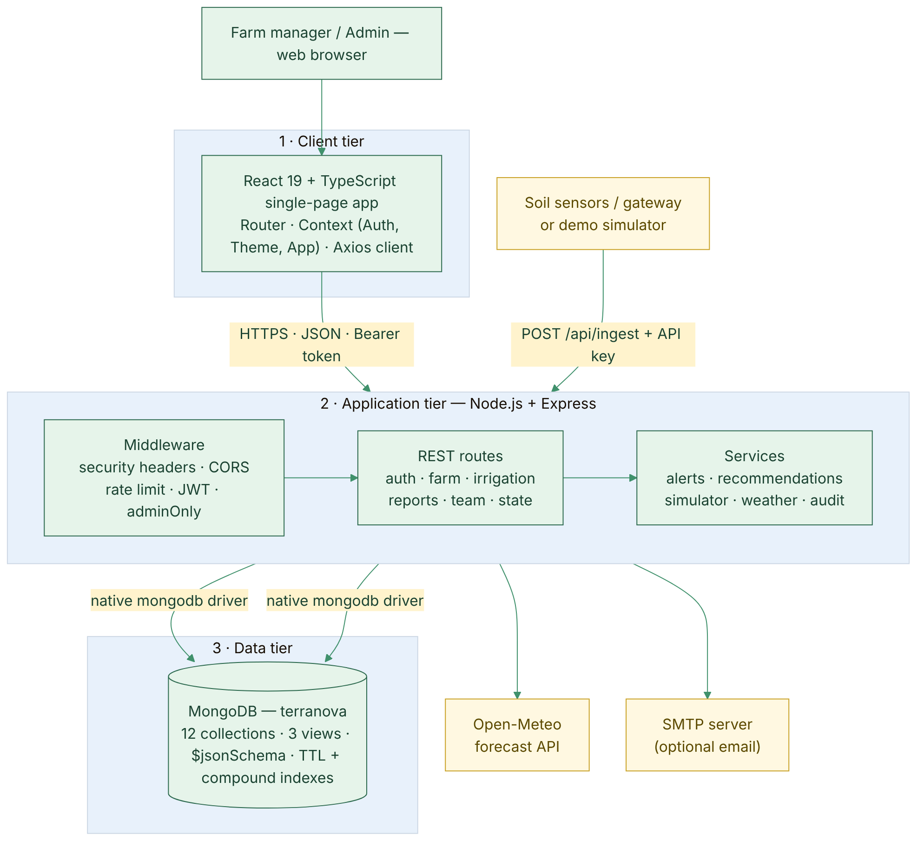
Figure 1 – System architecture of TerraNova
Figure 2 follows one request through the layers, using “schedule an irrigation event” as the example. The same path (token check, validation, database write, audit entry, JSON response) is used by every protected route.
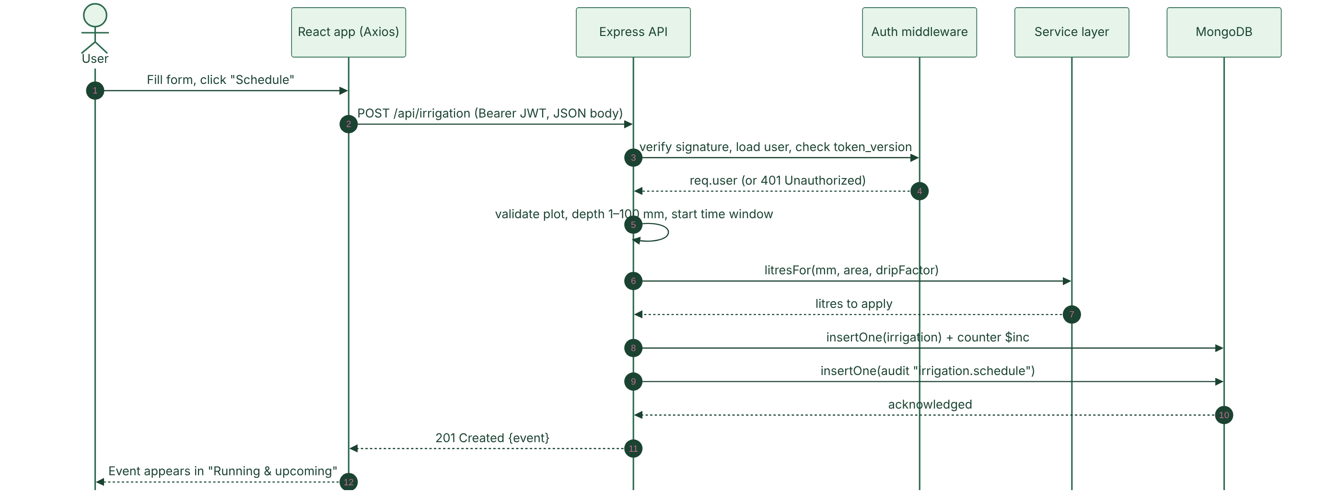
Figure 2 – Request and response path for scheduling an irrigation event

3.2 Modules and Workflow
Table 4 – Modules and their main functions
Module | Main Functions
Authentication and access | Login, JWT issue and verification, role checks (adminOnly), invitation accept, password change, token versioning to revoke old sessions.
Monitoring | Overview, plot detail, sensors, live data endpoint, manual readings, chart history, weather forecast.
Ingest and simulation | API-key protected /api/ingest (single or batch), validation, demo simulator that dries and re-wets plots.
Alerts and recommendations | Alert engine (syncAlerts), recommendation engine (buildRecs), acknowledge, schedule or dismiss.
Irrigation and fertigation | Scheduling, status transitions (start, complete, cancel), litre calculation, history with filters and paging.
Reports and export | Aggregation pipelines, weekly chart, Excel and CSV exports, print-ready PDF report.
Administration | Thresholds, plots, sensors, estate settings, team and invitations, audit log, database panel.

Figure 3 shows how data flows through the application in three stages: readings are ingested, the alert and recommendation engines decide what needs attention, and the user acts by scheduling and completing events. Completed irrigation raises soil moisture, which appears in the next readings and closes the loop.
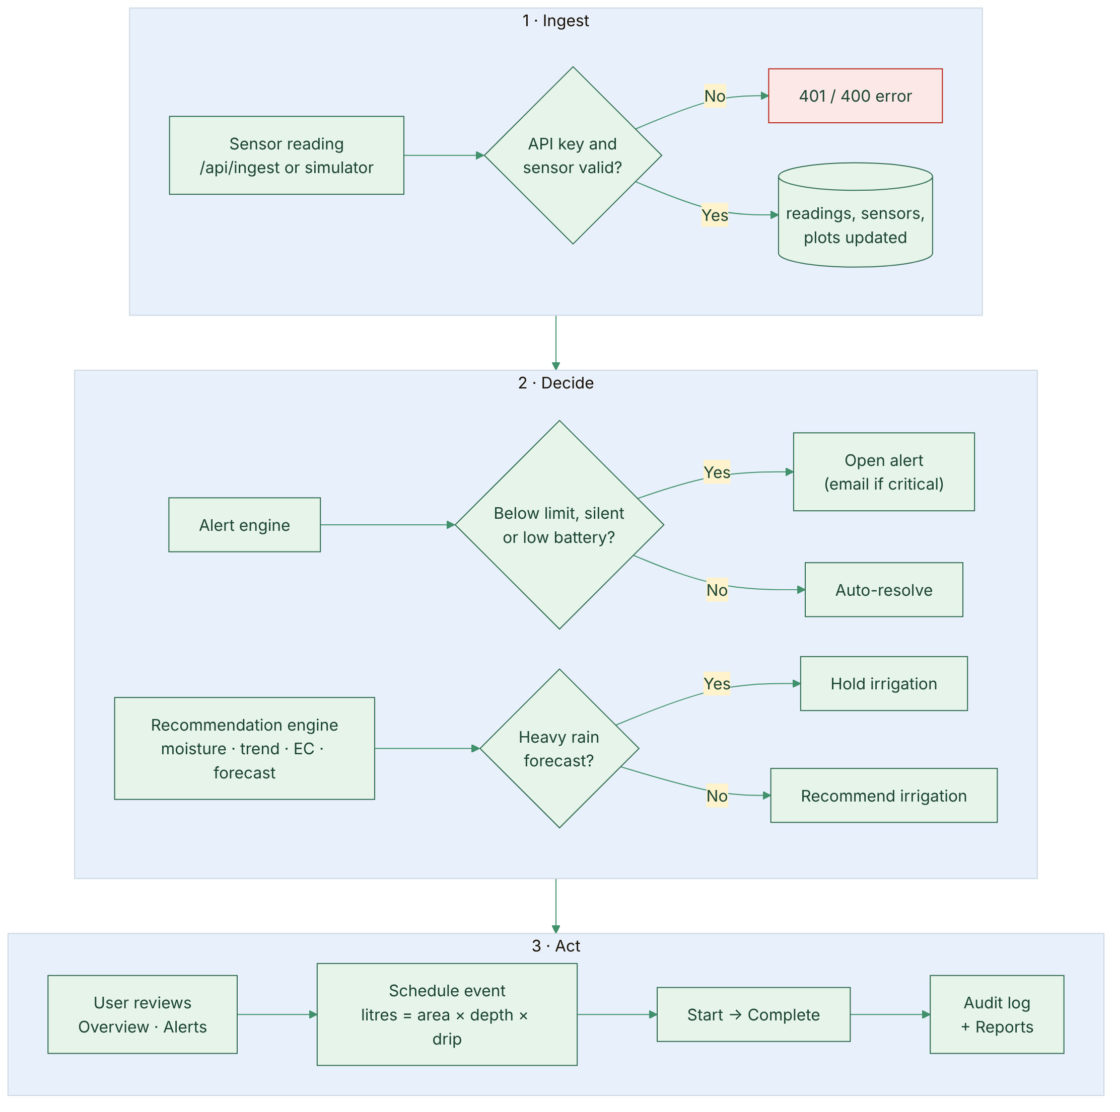
Figure 3 – Application workflow and data flow
Every irrigation event follows the fixed life cycle shown in Figure 4. The server enforces it, so a completed or cancelled event can no longer be changed.
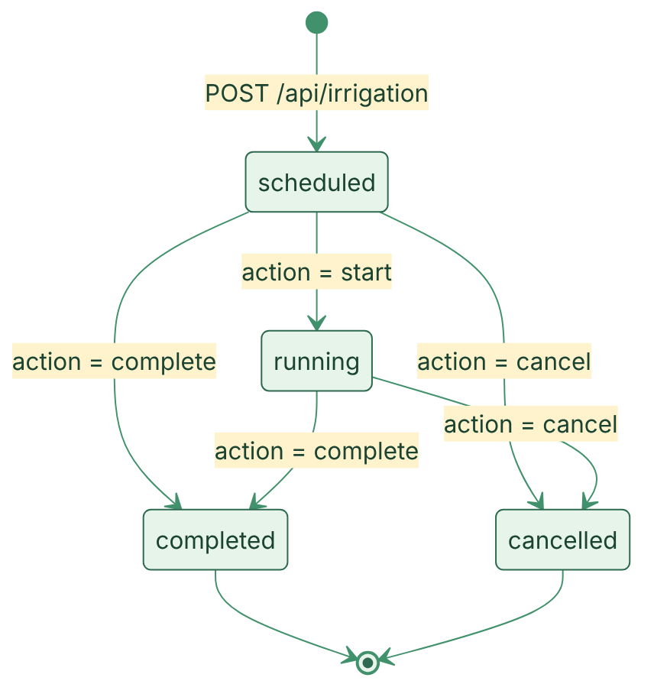
Figure 4 – Life cycle of an irrigation event

3.3 Database Design
The database terranova contains 12 collections and 3 read-only views. Plots, sensors, readings, irrigation events and alerts hold the farm data; users, team and invites hold access control; settings, rec_state and audit hold configuration, recommendation state and the activity log; counters hands out numeric ids. Relationships are by reference (for example readings.plot_id refers to plots._id), as shown in Figure 5.
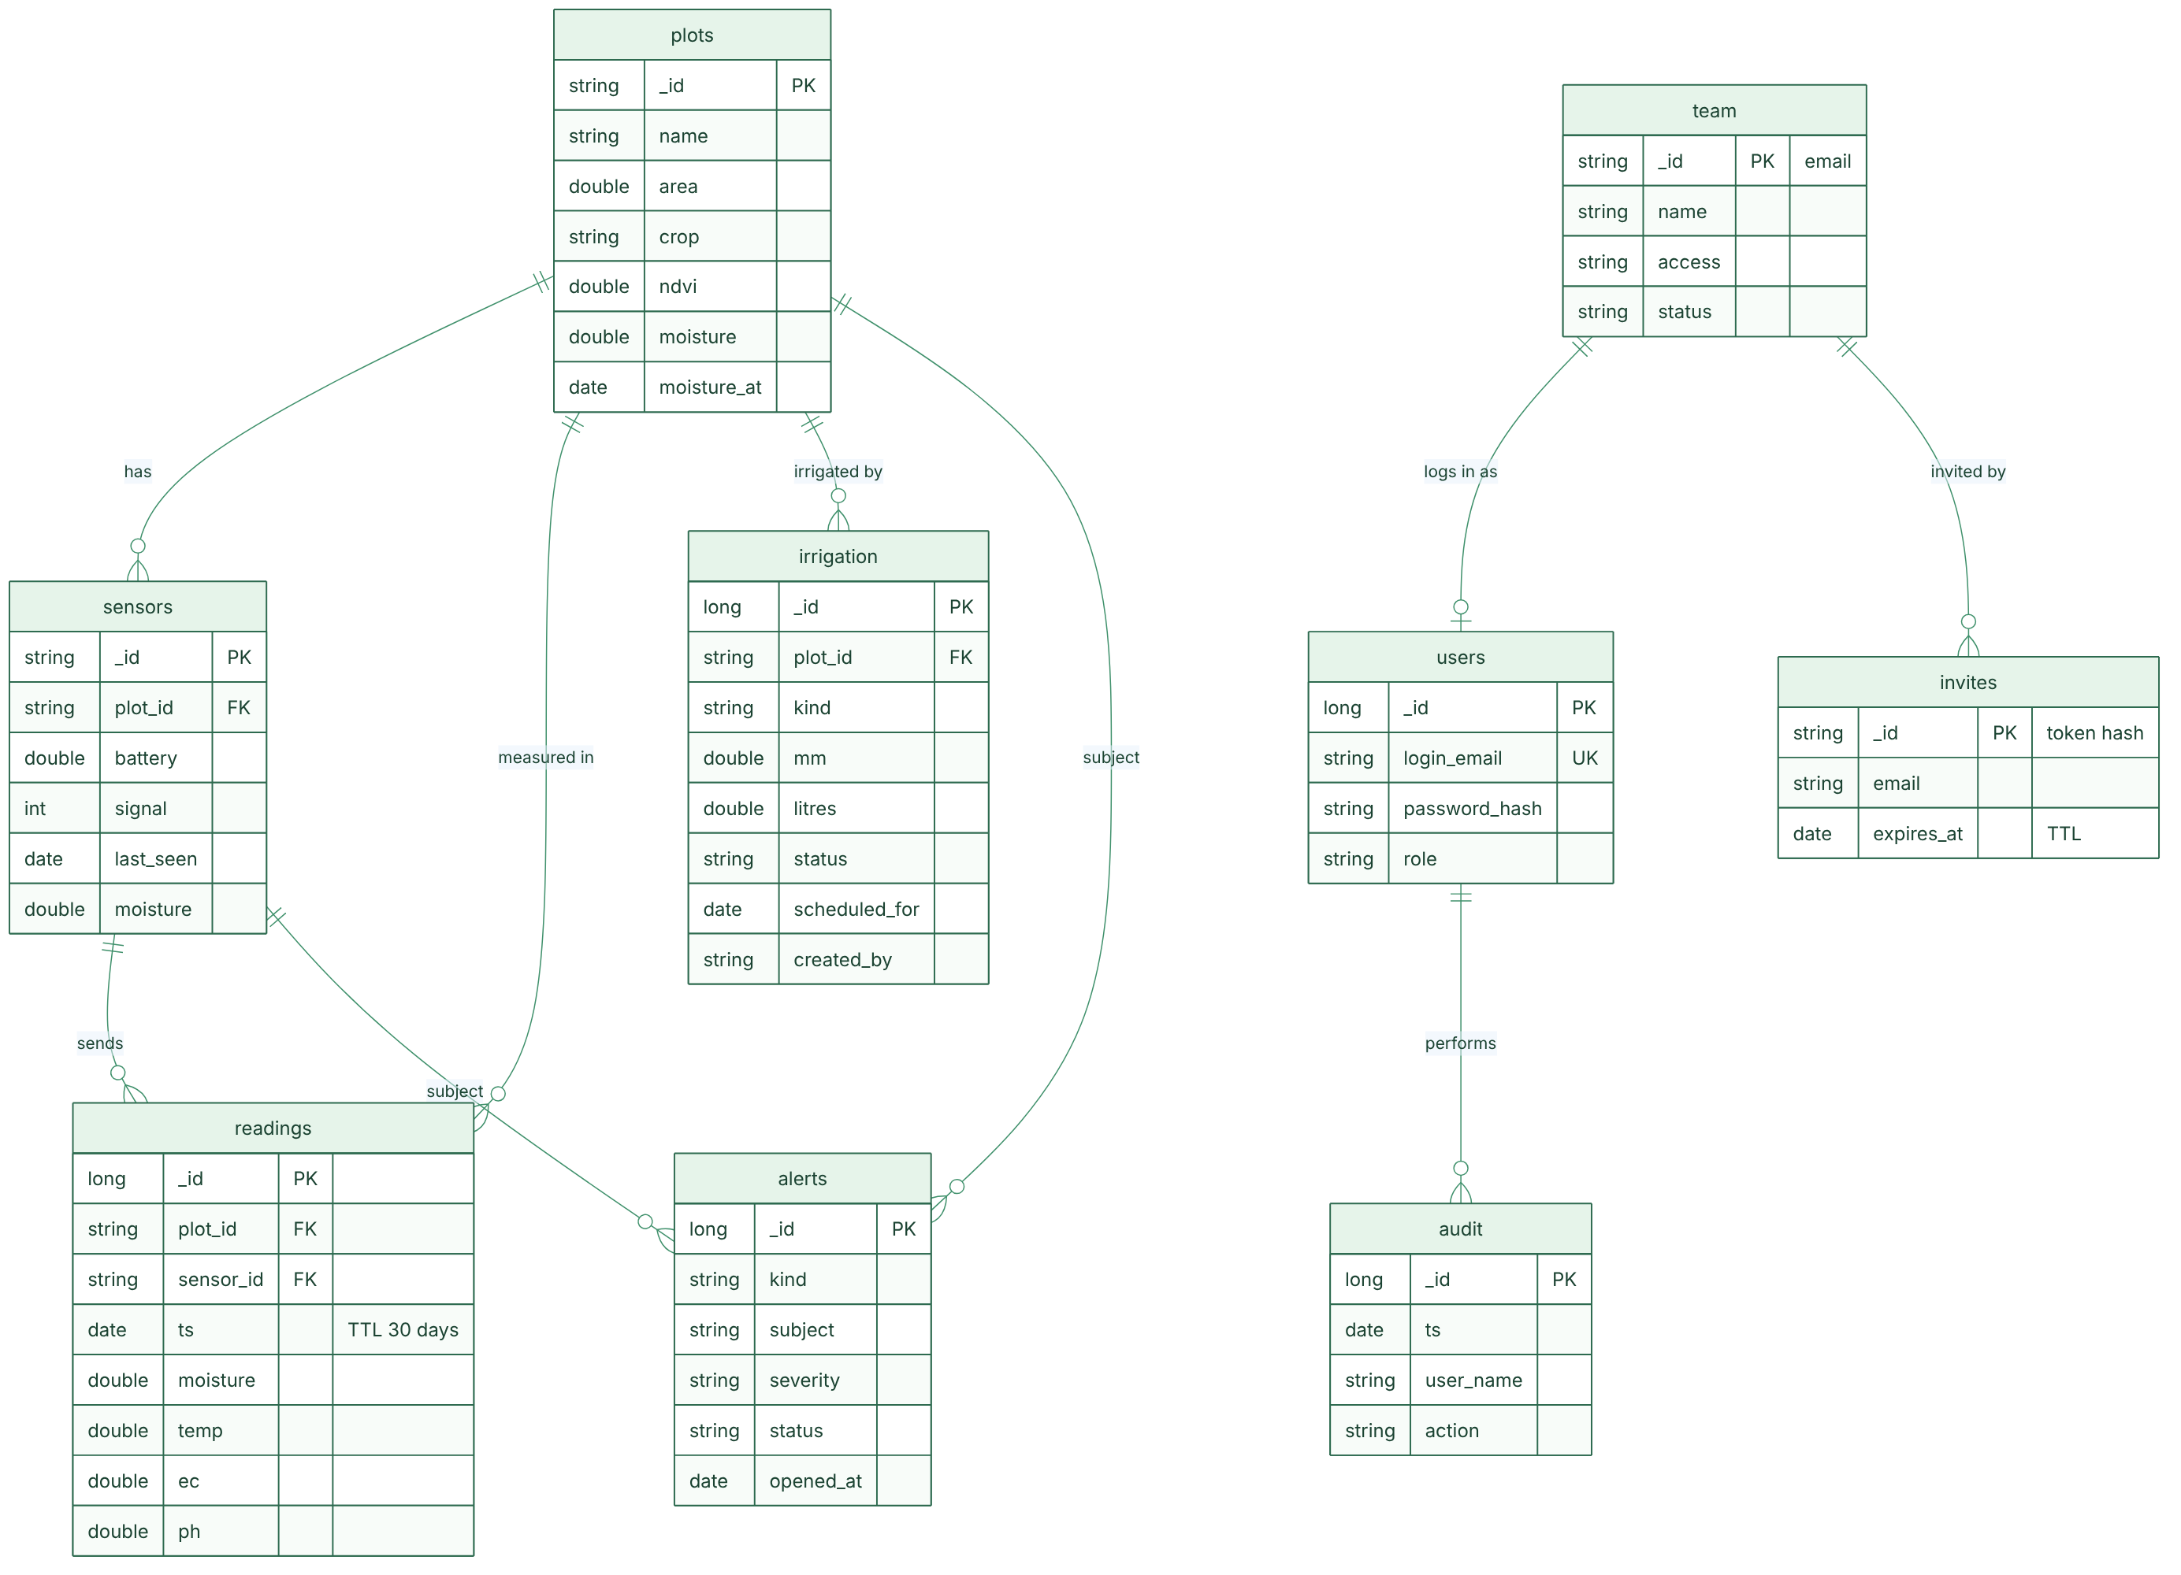
Figure 5 – Database design (collections and relationships)
Table 5 – Collections and important fields
Collection | Important Fields | Purpose
plots | name, area, crop, age, ndvi, moisture, moisture_at | The cane blocks being monitored
sensors | plot_id, depth, firmware, signal, battery, last_seen, moisture, temp, ec, ph | Registered soil sensors and their latest values
readings | plot_id, sensor_id, source, ts, moisture, temp, ec, ph | Time-series measurements (deleted after 30 days by a TTL index)
irrigation | plot_id, kind, mm, litres, status, scheduled_for, started_at, completed_at, created_by | Irrigation and fertigation events
alerts | kind, subject, severity, message, status, opened_at, ack_by, ack_at, resolved_at | Open and historical alerts
users | login_email (unique), password_hash, role, name, preferences, token_version | Accounts that can sign in
team, invites | team: name, role, status, access; invites: email, access, expires_at (TTL) | Estate team list and single-use invitations
settings, rec_state, audit, counters | key/value, state/until, ts/user_name/action/detail, seq | Configuration, dismissed recommendations, activity log, id sequences

Three views are computed by MongoDB itself: v_plot_overview (plots joined with latest sensor and open alerts), v_water_use_daily (litres per day from completed events) and v_open_alerts. Every collection carries a $jsonSchema validator, and indexes cover the main queries, for example readings (plot_id, ts) and irrigation (plot_id, scheduled_for).

3.4 API Design
The API is grouped by resource; all routes except sign-in, invitation acceptance, device ingest and health check require a bearer token, and routes marked “Admin” also require the admin role.
Table 6 – REST API endpoints
Method | Endpoint | Purpose
POST | /api/auth/login | Sign in; returns token and user
GET | /api/me · /api/bootstrap · /api/live | Current user; initial app data; live plots, sensors and alerts
POST | /api/plots (Admin) | Create a plot
GET | /api/plots/:id | Read one plot with history, sensors and events
PUT / DELETE | /api/plots/:id (Admin) | Update or delete a plot
POST | /api/plots/:id/readings | Add a manual moisture reading
POST / PUT / DELETE | /api/sensors · /api/sensors/:id (Admin) | Register, update or delete a sensor (history: /readings)
POST | /api/ingest | Device readings (API key; one or up to 100)
GET / POST | /api/irrigation | List events (filters and paging) / schedule an event
POST | /api/irrigation/:id/:action | start, complete or cancel an event
POST | /api/recommendations/:key/schedule · /dismiss | Act on a recommendation
GET / POST | /api/alerts · /api/alerts/:id/acknowledge | List alerts / acknowledge
GET | /api/reports/summary · /api/reports/export/:type | Report figures; CSV or Excel download
PUT | /api/thresholds · /api/settings (Admin) | Alert limits and estate settings
PUT / POST | /api/profile · /api/prefs · /api/auth/change-password · /api/api-key/regenerate | Own profile, preferences and password (revokes other sessions); new device key (Admin)
POST / DELETE | /api/team/invite · /api/team/:email (Admin) | Invite, re-invite (/reinvite) or remove a member
GET / POST | /api/invites/:token · /api/invites/accept | Check and accept an invitation
GET | /api/audit · /api/admin/database · /api/health | Activity log and database panel (Admin); health check

4. APPLICATION DESIGN AND IMPLEMENTATION

4.1 User Interface and Navigation
After sign-in, a top navigation bar gives access to Overview, Sensors, Irrigation, Alerts (with a live count of open alerts), Recommendations, Reports and, for administrators, Admin. A bell icon lists the latest open alerts and a profile menu offers account settings, dark mode and log out. The interface uses a green colour scheme suited to farming, rounded cards, colour-coded status chips and works in light and dark themes.
The Overview page (Figure 6) is the home screen: four KPI cards (total area, average moisture, optimal plots, open alerts) and a card for every plot with a moisture bar, NDVI and any planned irrigation.
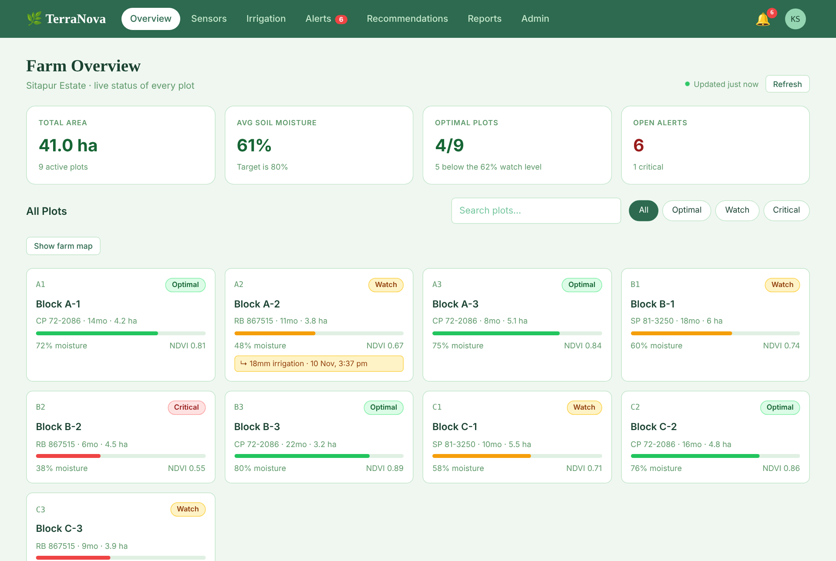
Figure 6 – Overview page with KPI cards and plot status
On the Irrigation page (Figure 7) the user chooses a plot, type, depth and start time in the “New event” card, follows running and upcoming events, and filters the history. All dropdowns are custom components that follow the website theme, open as rounded panels and can be used with the keyboard.
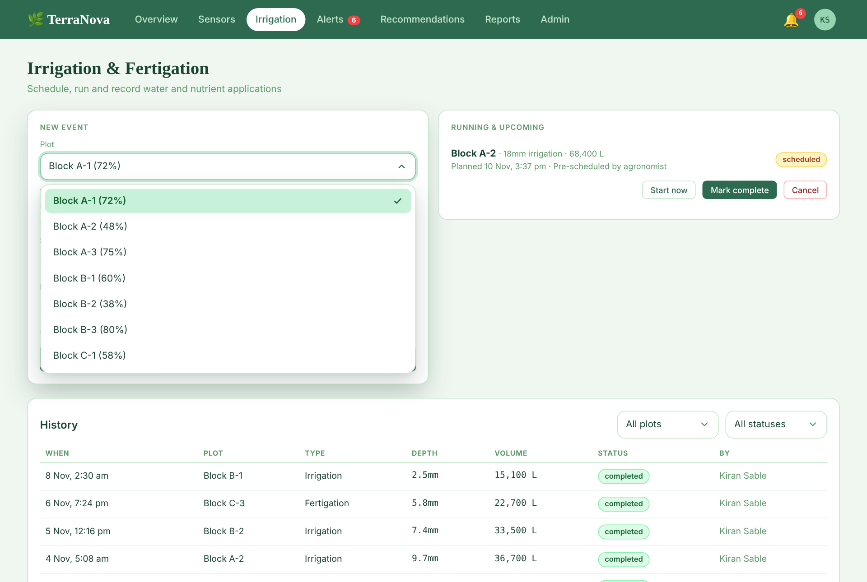
Figure 7 – Irrigation page with the themed dropdown open
The Reports page (Figure 8) offers 7, 30 or 90-day periods, an Export data menu and a Print / PDF button.
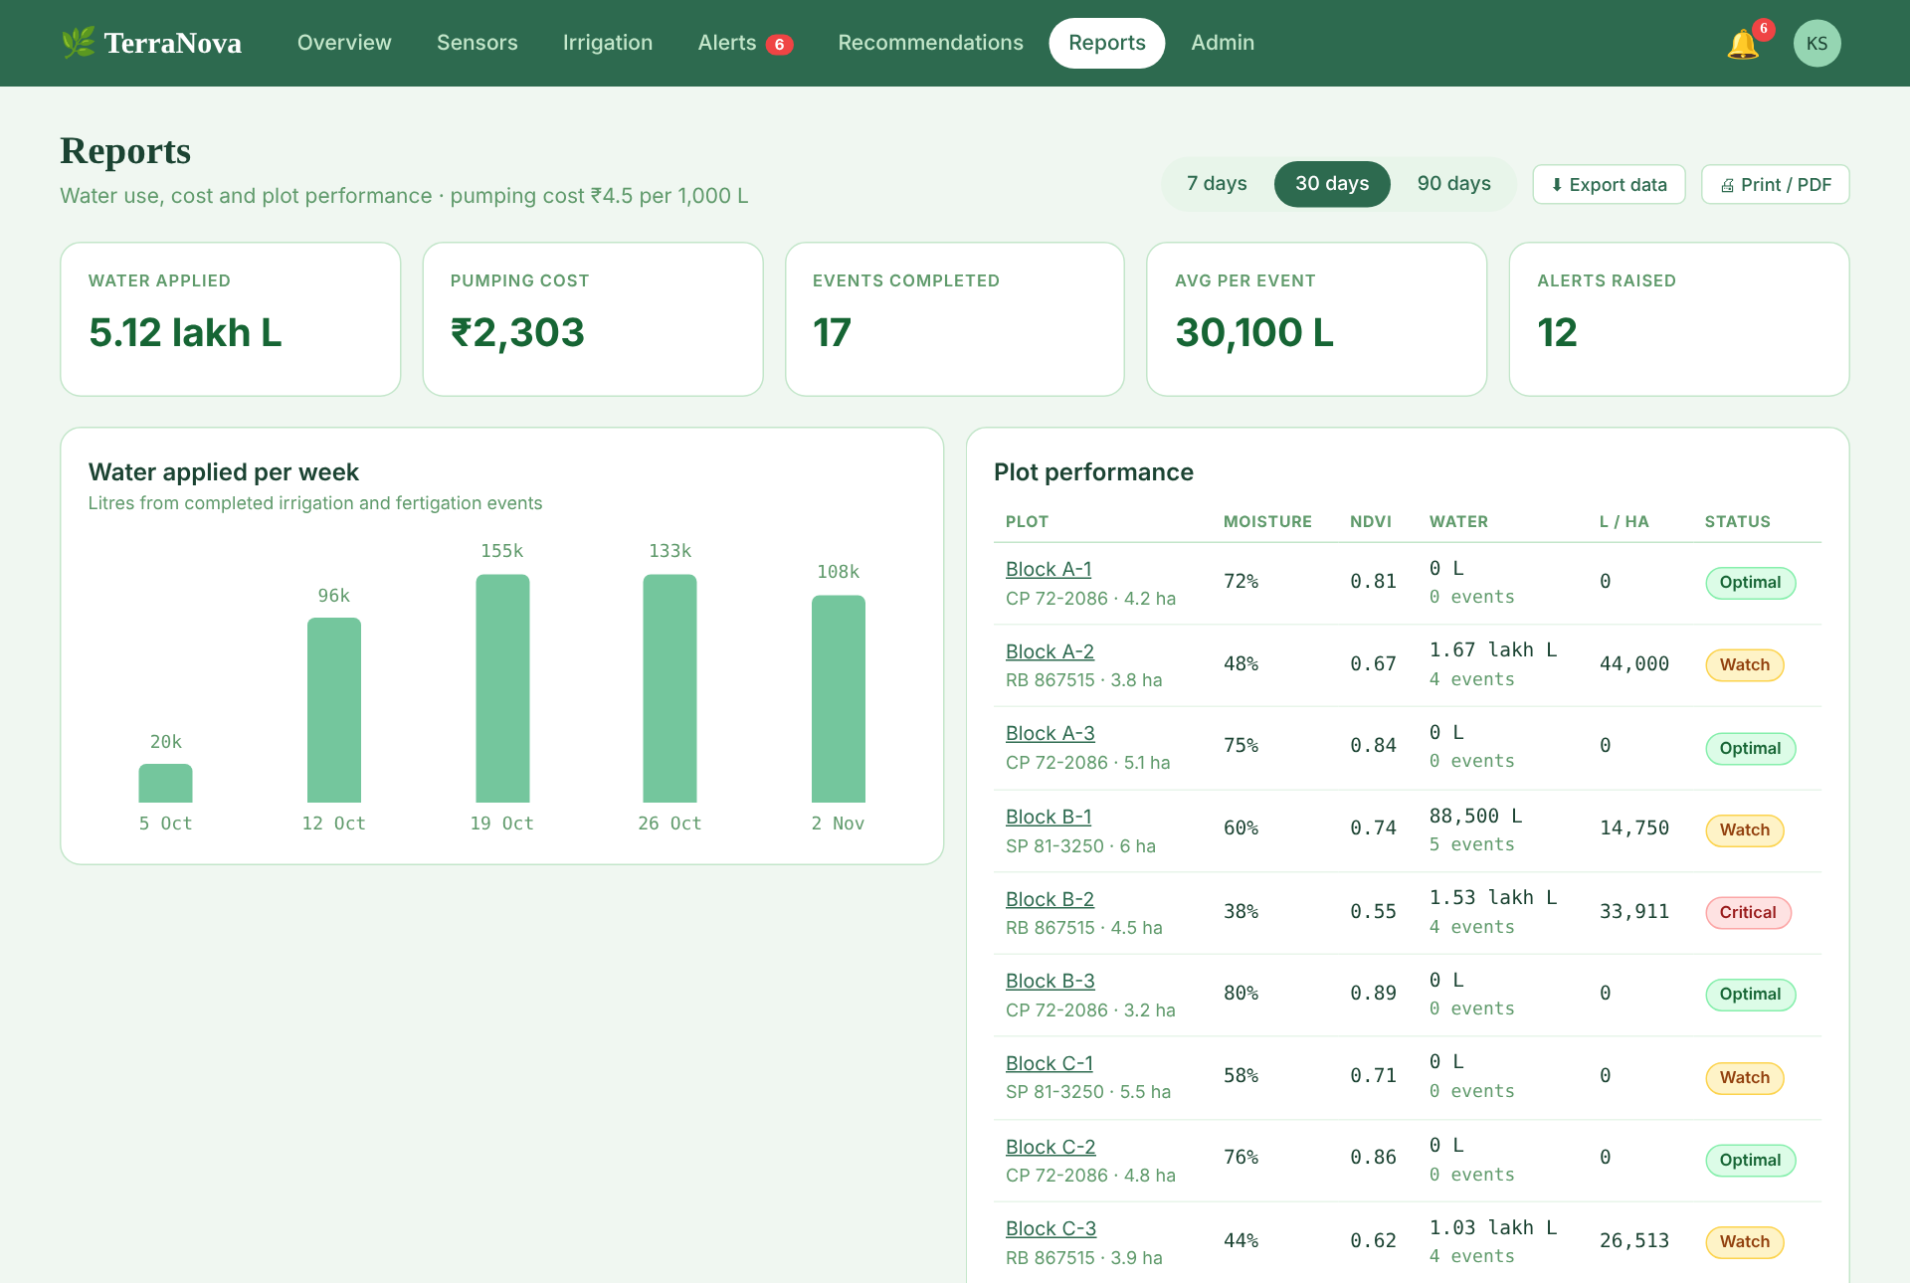
Figure 8 – Reports page with weekly water chart and plot performance

4.2 Frontend Implementation
The front end is a React 19 + TypeScript project built with Vite. Its main parts are:
- Routing: React Router maps the URLs to page components (Overview, PlotDetail, Sensors, Irrigation, Alerts, Recommendations, Reports, Admin, Account, Login, AcceptInvite). Admin routes are hidden from normal users and redirected.
- State: React context providers hold the signed-in user (Auth), the theme (Theme) and the shared farm data (App), which refreshes itself every 30 seconds. Local component state (useState, useEffect, useMemo) handles forms, filters and paging.
- API calls: all requests go through api.ts, an Axios client that attaches the bearer token, converts errors into a single ApiError with a readable message and signs the user out on a 401 response.
- Forms and feedback: controlled inputs with immediate validation messages, toast notifications for success and errors, and confirmation before destructive actions.
- Reusable components: Popover (menus), cards, status badges and Select, a themed dropdown rendered in a portal so it is never clipped, with arrow-key, Home/End, Enter, Escape and type-ahead support.
- Reports: the screen view and a separate print-only report share the same data; print styles produce a clean A4 layout with SVG bars so that colours print correctly.

4.3 Backend and API Implementation
The back end is an Express application assembled in app.js. A request passes through this middleware chain: security headers and a Content-Security-Policy, CORS, JSON body parsing limited to 200 KB, a rate limiter (600 requests per minute per client), and the route handler. Protected routes use the auth middleware, which verifies the JWT, loads the user from MongoDB, checks the token version and rejects invalid callers with 401; adminOnly returns 403 for non-admins.
Routes are split into modules (auth, farm, irrigation, reports, team, state, database) and share a ctx object containing the database layer and helpers. Business logic lives in services: alerts.js opens and resolves alerts, recs.js builds recommendations, simulator.js generates demo readings, weather.js fetches the forecast, mailer.js sends optional e-mail and audit.js writes the activity log. Handlers always answer with JSON: a success body or { "error": "message" } with a suitable status code (400, 401, 403, 404, 409 or 429). Unknown API paths return 404 and a final error handler prevents stack traces from reaching the client. In production the same server also serves the built React files.

4.4 Database and CRUD Implementation
server/src/db.js wraps the native MongoDB driver. A mapping table in schema.js converts between the flat “row” shape used by the API and MongoDB documents (the key becomes _id, timestamps become BSON dates, flags become booleans). On start-up the server creates every collection with its $jsonSchema validator, indexes and views, and loads the demo data if the database is empty. Numeric ids come from the counters collection using an atomic findOneAndUpdate with $inc. Table 6 shows how each CRUD operation is carried out, using plots and irrigation events as examples.
Table 7 – CRUD operations in the application
CRUD | Frontend Action | Backend / Database Action
Create | Admin → Plots & sensors → Add plot; Irrigation → “Schedule event”; Plot detail → manual reading | POST /api/plots, /api/irrigation, /api/plots/:id/readings → validate input → insertOne (id from counters) → audit entry
Read | Overview, Plot detail, Irrigation history, Reports | GET /api/live, /api/plots/:id, /api/irrigation, /api/reports/summary → find with filters, paging and sort; aggregate for reports; views for summaries
Update | Admin → edit plot, sensor or thresholds; Start / Mark complete / Cancel an event | PUT /api/plots/:id, /api/sensors/:id, /api/thresholds; POST /api/irrigation/:id/:action → status transition check → updateOne
Delete | Admin → delete plot or sensor; remove team member; Cancel event | DELETE /api/plots/:id, /api/sensors/:id, /api/team/:email → related documents handled → deleteOne / deleteMany

4.5 Validation and Error Handling
Input is validated twice: by the API before anything is written, and by MongoDB’s $jsonSchema validators as a second safety net. Three representative examples:
Table 8 – Validation and error-handling examples
Situation | How it is handled | Result for the user
Irrigation depth outside 1–100 mm, no plot chosen, or start time outside the next 90 days | Handler checks num(mm, 1, 100), the plot lookup and the time window before any insert | HTTP 400 with “Depth must be between 1 and 100 mm.” / “Choose a plot.”; shown as a message on the form
Wrong password, or too many attempts | Same message for unknown e-mail and wrong password; sign-in is blocked for 15 minutes after 8 failed attempts | HTTP 401, then 429 “Too many attempts”
Duplicate account e-mail or invalid document | Unique index on users.login_email and $jsonSchema validators reject the write | The database error is caught and turned into a clear message; nothing is stored
Expired or missing token, or a user calling an admin route | auth and adminOnly middleware | HTTP 401 signs the user out; HTTP 403 “Admin access required”

On the front end, Axios interceptors turn network failures into the message “Can’t reach the server. Check your connection and try again.” and every page shows loading and error states instead of an empty screen.

5. TESTING AND RESULTS

5.1 Testing Approach
The testing carried out was:
- Automated API integration tests: server/test/api.test.js starts the real Express application and calls it over HTTP, checking status codes, response bodies and the stored data. It contains 23 test groups. By default the tests run against a small in-memory stand-in for MongoDB (so they need no database server); the same suite can be pointed at a real MongoDB with TEST_MONGODB_URI=mongodb://127.0.0.1:27017 npm test.
- Manual and visual testing in the browser: every page was opened in light and dark themes; forms, dropdowns, exports and the print preview were exercised by hand.
- Database verification: the collections, documents, indexes and validators were inspected in MongoDB Compass (Figure 10) and in the Admin → Database panel.
Note: API testing was done with the project’s own automated test suite rather than Postman, so no Postman screenshots are included.

5.2 Test Cases
Table 8 lists selected test cases. The automated groups were executed with npm test and all 23 passed (Figure 9).
Table 9 – Selected test cases and results
ID | Test Scenario | Expected Result | Actual Result | Status
TC01 | Sign in with valid and invalid credentials; security headers present | Token issued for valid login; 401 for invalid; headers set | As expected (group “auth + security headers”) | PASS
TC02 | User calls an admin-only route | Request is refused | HTTP 403 returned (group “admin-only routes are blocked for users”) | PASS
TC03 | Create, edit, validate and delete a plot; add a manual reading | Records created, changed and removed; bad input rejected | As expected (group “plots: create, validate, edit, manual reading, delete”) | PASS
TC04 | Device posts readings with the API key | Reading stored; invalid key or unknown sensor rejected | As expected (group “sensors + device ingest”) | PASS
TC05 | Schedule an irrigation event with depth outside 1–100 mm | HTTP 400 and no record | HTTP 400 returned; valid events returned 201 and moved through start, complete and cancel (group “irrigation lifecycle + validation”) | PASS
TC06 | Recommendations: schedule, dismiss, rain hold | Irrigation created; dismissed advice hidden; rain forecast produces a hold advisory | As expected (group “recommendations…”) | PASS
TC07 | Low moisture, offline sensor or low battery | Alert opened, acknowledged and resolved automatically | As expected (groups “thresholds drive alerts”, “alerts + acknowledge”) | PASS
TC08 | Invite a team member, accept the link, sign in, remove the member | Single-use link works; removed user loses access | As expected (group “team invites…”) | PASS
TC09 | Change password | Old sessions are signed out | Old token rejected (group “password change signs out old sessions”) | PASS
TC10 | Reports and exports (CSV, Excel, print summary) | Readable CSV in the viewer’s time zone; workbook with expected sheets | As expected (four report groups) | PASS
TC11 | Database tab, views and demo data | Admin only; collections, views and indexes listed; views follow the data | As expected (groups “Database tab…”, “views are computed by MongoDB…”) | PASS
TC12 | Restart the server; duplicate e-mail insert; load data from database/collections | Data persists; unique index rejects duplicate; app runs on the imported database | As expected (last three groups) | PASS

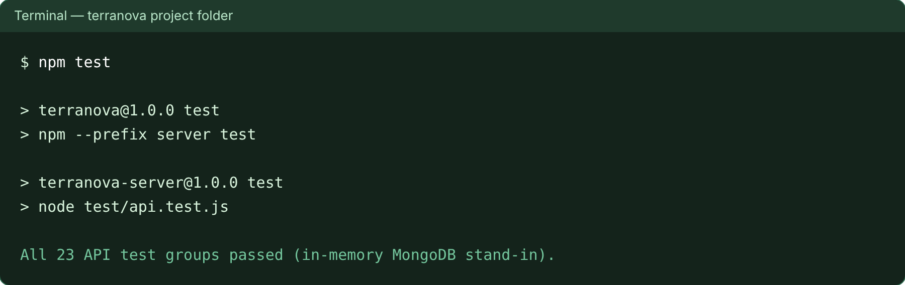
Figure 9 – Output of the automated test suite (npm test)

5.3 API and Database Verification
Figure 10 shows the terranova database in MongoDB Compass using the connection imported from database/terranova-compass-connections.json. All 12 collections are present and the plots collection holds the nine blocks, with dates stored as real ISODate values. The same information (collections, documents, size, indexes and schema rules) is available inside the application under Admin → Database.
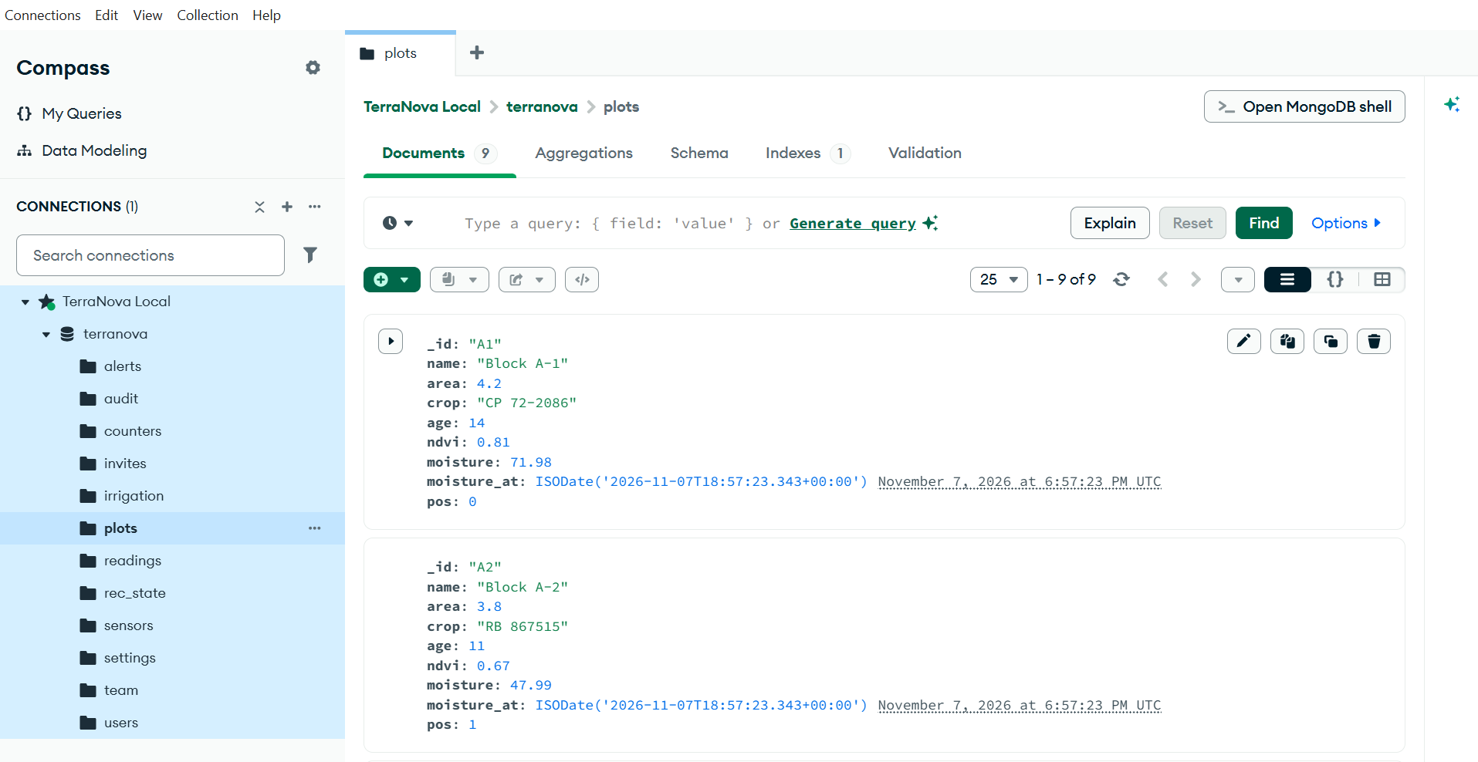
Figure 10 – MongoDB Compass showing the terranova database and plots collection

5.4 Final Results
All eleven functional requirements (FR1–FR11) were implemented and tested, and all 23 automated test groups passed. The Excel and CSV exports open with readable headers and local times, and the printed report fits on A4 pages with its charts and status chips visible. The project has not been deployed to a public server (Section 6.2), and the automated tests ran against the in-memory MongoDB stand-in (see Section 5.1 for running them on a real MongoDB).

6. GITHUB AND DEPLOYMENT

6.1 GitHub Repository
The source code is hosted at https://github.com/sushantsamant-616/terranova. The repository contains the React front end, the Express and MongoDB back end, the MongoDB Compass files, screenshots, a MIT licence and a README with set-up instructions, feature list, API summary and the list of MongoDB features used. A GitHub Actions workflow (.github/workflows/ci.yml) installs the dependencies, runs the test suite and builds the front end on every push and pull request. Figure 11 shows the repository structure.
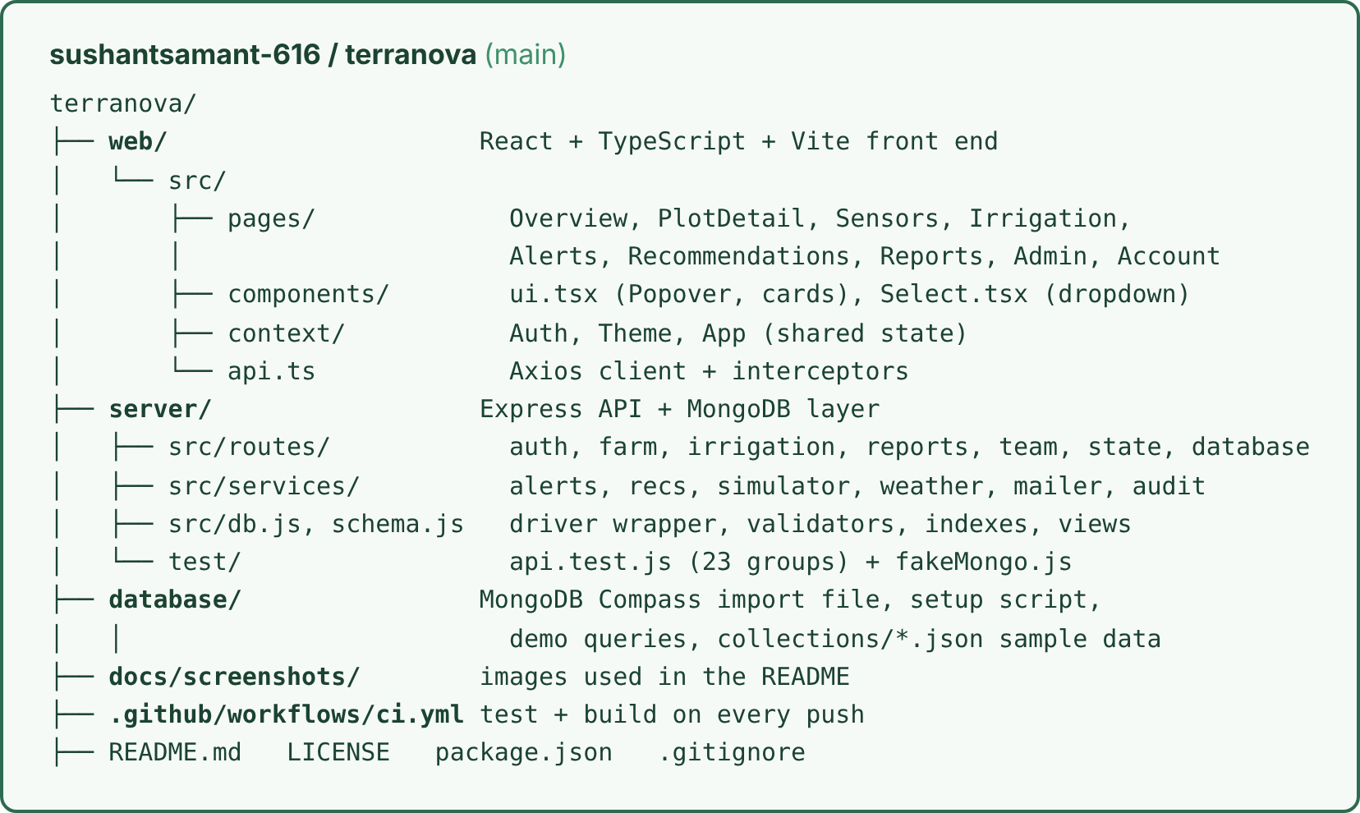
Figure 11 – GitHub repository structure
The team used Git for version control with a main branch, committed working changes with descriptive messages and kept build output, node_modules and database files out of the repository through .gitignore.

6.2 Deployment Details
Table 10 – Deployment details
Item | Details
GitHub Repository | https://github.com/sushantsamant-616/terranova
Frontend URL | N.A. (served locally by the Express server at http://localhost:4000 after npm run build; development server at http://localhost:5173)
Backend URL | N.A. (http://localhost:4000/api)
Database | MongoDB Community Server (local), mongodb://127.0.0.1:27017/terranova, inspected with MongoDB Compass; MongoDB Atlas can be used by setting MONGODB_URI
Deployment Platform | N.A. The project runs locally; it can be hosted on a platform such as Render or Railway with MongoDB Atlas

To run the project: npm run setup, npm run build, npm start, then open http://localhost:4000. Demo logins are listed in the README.

7. CHALLENGES AND INDIVIDUAL CONTRIBUTIONS

7.1 Challenges and Solutions
Table 11 – Challenges, solutions and outcomes
Challenge | Solution | Outcome
Moving the data layer from SQL-style rows to MongoDB documents without rewriting every route | A mapping layer in db.js and schema.js converts rows to documents (key to _id, dates to BSON dates, booleans); numeric ids come from an atomic counters collection | The API kept its shape and all 23 test groups pass on MongoDB-shaped data
Keeping MongoDB data clean | $jsonSchema validators, unique and TTL indexes and three views created on start-up and by database/terranova-setup.js | Invalid data is rejected by the database itself; old readings expire automatically
Export menu on the Reports page opened behind the cards and could not be clicked | Found that animated cards create stacking contexts; gave the page header, popover and panel explicit z-index values | The menu opens above all content and every export works
Printed report lost its chart bars and spilled onto extra pages | Built a dedicated print-only report with SVG bars, print-color-adjust: exact, @page margins and stacked tables | Clean A4 report with visible charts and colours, light theme even in dark mode
Exports were hard to read in Excel | Friendly headers, times in the viewer’s time zone, rounded numbers, UTF-8 byte-order mark, and a styled workbook made with exceljs | Files open correctly with readable data
Browser’s default dropdown did not match the design and was clipped inside cards | Created a reusable Select component drawn in a portal with fixed positioning and keyboard support | Rounded, themed dropdowns on every page in light and dark mode

7.2 Individual Contributions
The work of the project was divided among the three team members as shown in Table 12. Each member built a set of pages on the front end, the matching API routes on the back end, the related MongoDB collections, and tested the same features.
Table 12 – Individual contributions
Student | Frontend | Backend / API | Database | Testing / Deployment
Sushant Samant | Developed the Overview dashboard, KPI cards, plot cards and navigation components using React and TypeScript. | Implemented irrigation scheduling APIs, event status transitions and irrigation volume calculation logic. | Designed and implemented the irrigation and plots collections with their required fields and relationships. | Tested irrigation scheduling, event completion and cancellation workflows. Verified API responses and application functionality.
Diva Shah | Developed the Irrigation, Alerts and Recommendations pages, including forms, filters, dropdowns and status indicators. | Implemented alert management, recommendation generation and sensor data ingestion APIs. | Worked on sensor, readings and alerts collections, including their validation rules and indexes. | Tested sensor monitoring, alert generation, acknowledgement and recommendation workflows.
Palak Sanklecha | Developed the Reports, Sensors and Administration interfaces, including charts, data tables and responsive UI components. | Implemented authentication, user management, reports and export-related API functionality. | Worked on users, team, invites and settings collections, including database validation and configuration. | Performed frontend testing, verified database operations and checked Excel, CSV and PDF report exports.

8. CONCLUSION AND FUTURE SCOPE

8.1 Conclusion
TerraNova addresses a real problem on sugarcane estates: irrigation decisions that are taken without a clear, current picture of each plot. The project delivers a complete MERN application in which sensor readings are collected, alerts are raised automatically, recommendations are generated from moisture, trend, salinity and the weather forecast, and every irrigation event is scheduled, run and recorded. Reports can be exported to Excel and CSV or printed as a PDF, so that water use and cost can be reviewed.
On the technical side, the React front end communicates with the Express API through Axios, the API enforces authentication, roles and validation, and MongoDB stores all data with schema validation, indexes, TTL clean-up, aggregation pipelines and views. Full create, read, update and delete operations are implemented, 23 groups of automated API tests pass, and the code, documentation and a CI workflow are available on GitHub. The result is a working, secure and maintainable system that meets the objectives set at the start of the project.

8.2 Future Scope
- Deploy the application online (for example on Render or Railway with MongoDB Atlas) over HTTPS.
- Connect real soil-moisture hardware through LoRaWAN or Wi-Fi gateways using the existing ingest API.
- Deliver SMS and push notifications; the preferences are already stored but messages are not yet sent.
- Automate pumps and valves so approved irrigation events start and stop without manual action.
- Use machine-learning models to predict moisture and water demand instead of rule-based advice.
- Add a mobile application and multi-estate support with finer-grained roles.
- Add end-to-end browser tests and run the test suite against a real MongoDB in CI.

References
[1] React, “React documentation,” https://react.dev/.
[2] OpenJS Foundation, “Express – Node.js web application framework,” https://expressjs.com/.
[3] MongoDB Inc., “MongoDB Manual: schema validation, indexes, TTL indexes, aggregation and views,” https://www.mongodb.com/docs/manual/.
[4] OpenJS Foundation, “Node.js documentation,” https://nodejs.org/docs/latest/api/.
[5] Vite, “Vite documentation,” https://vite.dev/.
[6] Axios, “Axios documentation,” https://axios-http.com/docs/intro.
[7] M. Jones, J. Bradley and N. Sakimura, “JSON Web Token (JWT),” RFC 7519, IETF, 2015, https://datatracker.ietf.org/doc/html/rfc7519.
[8] Open-Meteo, “Open-Meteo weather forecast API,” https://open-meteo.com/en/docs.
[9] GitHub, “GitHub Actions documentation,” https://docs.github.com/actions.

